liPractical No:03
Configuration Extended ACL

- Network
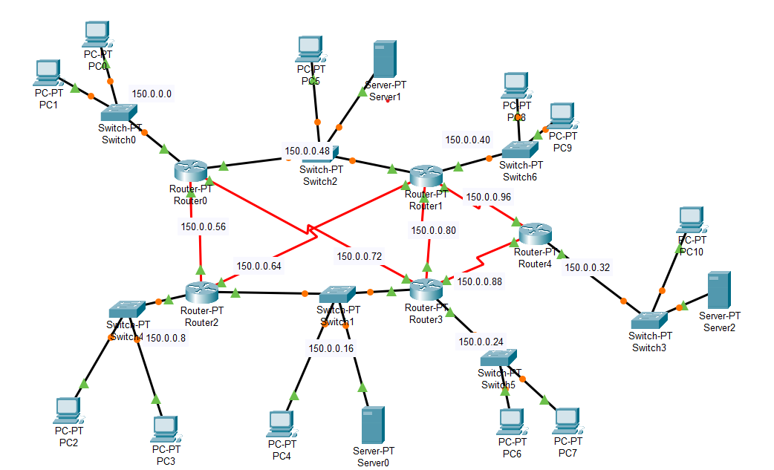

- Telnet (Teletype Network)
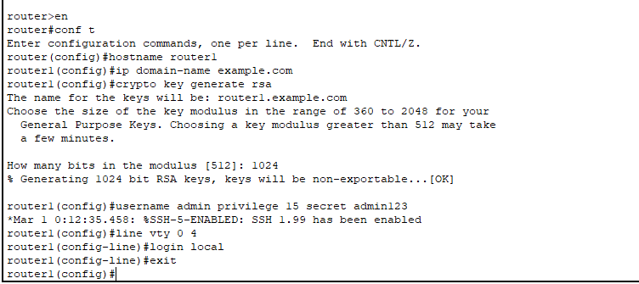

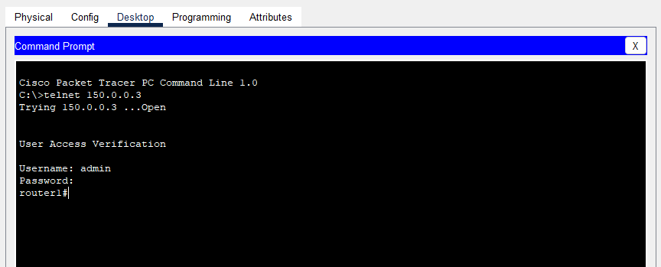

- SSH (Secure Shell) 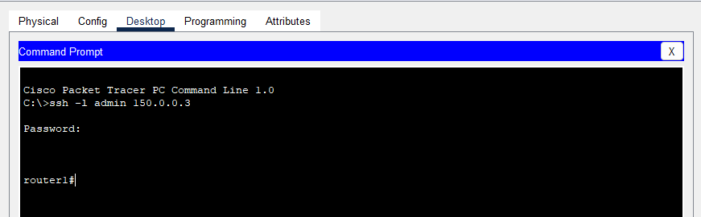

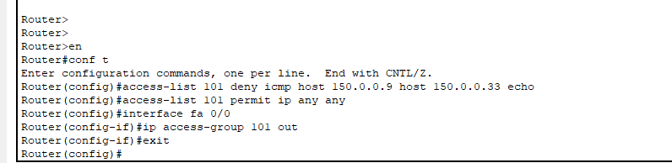
- ACL (Access Control List)

Accessing Server from blocked PC
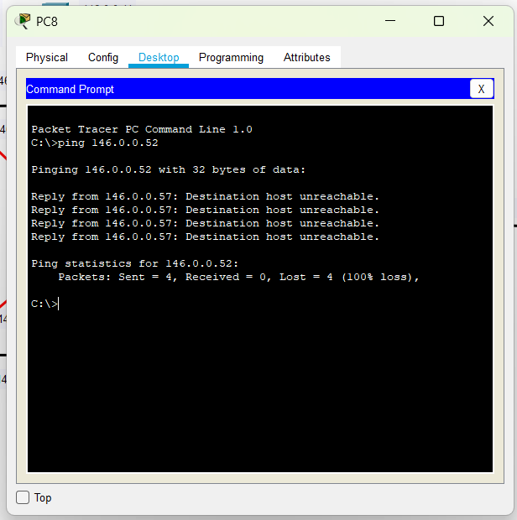
- Accessing Server from Other PC
